EXPLANATION OF CARTER COORDINATE SYSTEM (BULLETIN 62)
The Carter Coordinate System is patterned after the Township and Range system of land division. Township and range quadrangles are 6 miles square and are divided into 36 equal sections each 1-mile square. Carter coordinate quadrangles are 5-minute rectangles of latitude and longitude (approximately 7 ½ miles long by 5 ½ miles wide in Tennessee) and are divided into twenty-five 1-minute sections.
Certain modifications of the Carter Coordinate System as used in Kentucky are required in Tennessee. The Kentucky system starts at Long. 89° 30' W. and Lat. 36° 30' N. as a zero-point. North of Lat. 36° 30' N., in northern Tennessee and throughout Kentucky, "townships" are designated A, B, C, etc. South of this latitude, “townships” are designated 1S, 2S, 3S, etc. Because Tennessee extends westward beyond the longitude of the zero-point used in Kentucky, 89° 30' W., the system of designating “ranges” is slightly different in the two states. “Ranges” east of the zero point are designated 1, 2, 3 etc., in Kentucky and correspondingly 1E, 2E, 3E, etc. in Tennessee. For that portion of Tennessee west of the zero point, “range” numbers 1W, 2W, 3W, etc., have been assigned.
The area within each quadrangle is divided into twenty-five 1-minute sections. These sections are numbered starting with 1 in the northeast section and ending with 25 in the southwest section (see illustration).
Notice that locations are given in reverse order or from the smallest subdivision to the largest. For example, in the illustration the location of the well is in the NE quarter of the NE quarter of the SE quarter of section 11 of grid A-54E. It is readily seen that to find a well when the location is given, it will be necessary to read the location in reverse, finding grid A-54E first, then section 11, and finally the quarter subdivisions, SE NE NE.
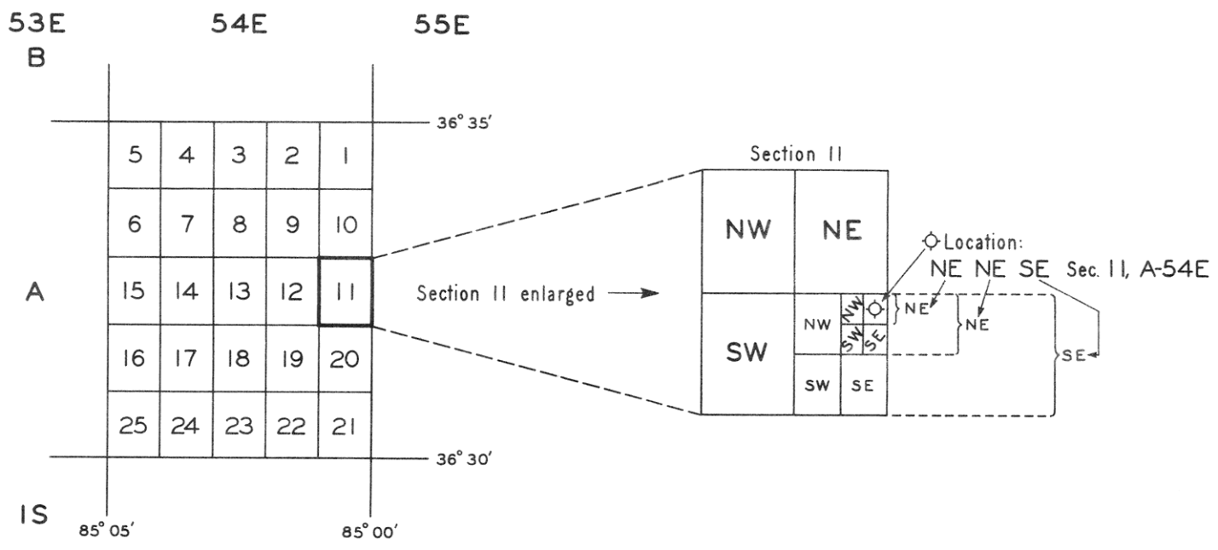

EXPLANATION OF CARTER COORDINATE SYSTEM (BULLETIN 76)
The Carter Coordinate System is patterned after the Township and Range System of land division. The Township and Range quadrangles are 6 miles square and divided into 36 equal sections of one-mile squares. Carter Coordinate quadrangles are 5-minute rectangles of latitude and longitude (approximately 7-1/2 miles long by 5-1/2 miles wide in Tennessee) and are divided into 25 one-minute sections. Each section is approximately one mile wide and one and one-tenth miles long.
The numerical arrangement of these 25 sections and the method of expressing the precise location of a well within a section is illustrated diagrammatically (see illustration). Notice that each topographic quadrangle covers all of one Carter Coordinate quadrangle and parts of three others.
The Carter Coordinate System as used in Tennessee and Kentucky starts at Long. 89° 30' W. and Lat. 36° 30' N. as the zero point. North of Lat. 36° 30' N. in northern Tennessee and throughout Kentucky “townships” are designated A, B, C, etc. South of this latitude “townships” are designated 1S, 2S, 3S, etc. “Ranges” east of the zero point are designated 1, 2, 3, etc. in Kentucky and correspondingly 1E, 2E, 3E, etc. in Tennessee, and for that portion of Tennessee west of the zero point, “range” numbers 1W, 2W, 3W, etc. have been assigned.
